Prepared by: Ahmed Essam Eldin

SALES DATA ANALYTICS DOCUMENTATION

SALES DATA ANALYTICS
1- Data Transformation:
1.1 Data Ingestion:
- Reading Data from 2 JSON us Pandas.
- Forecast table consists of 4 Columns {CountryRegion, Brand, Forecast, Year}.
- Sales table consists of 18 Columns.
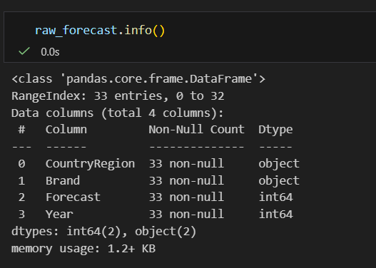
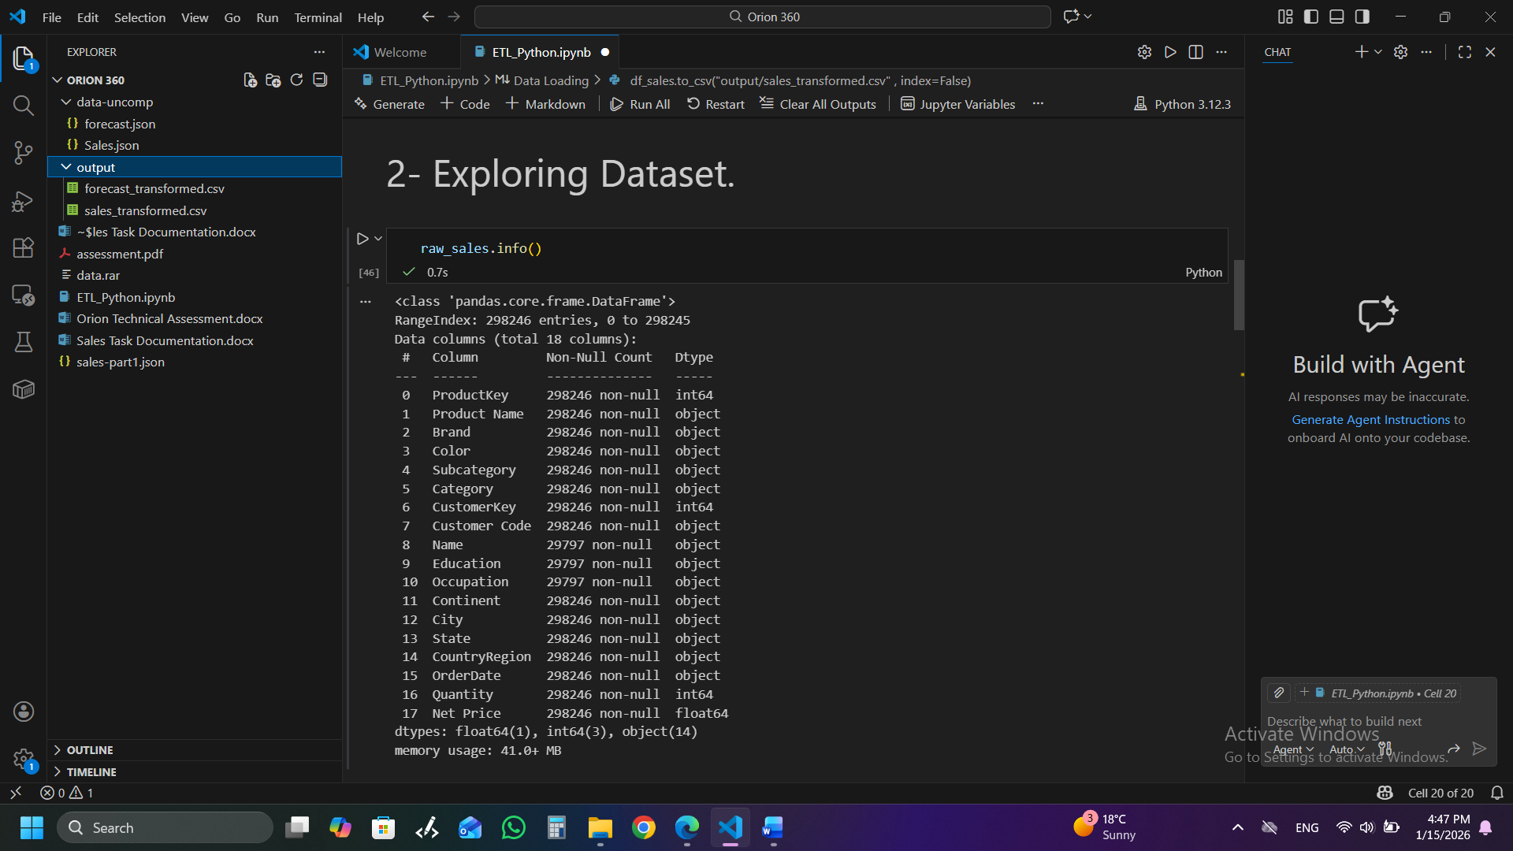

1.2 Cleaning:
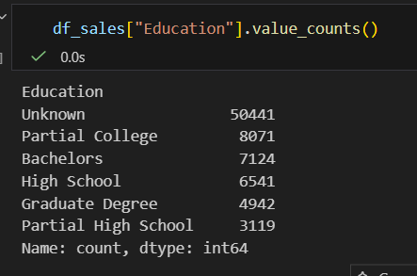
- Removing white spaces and extra char using strip().
- only 3 columns in Sales table contain 268449 null values which are {Name, Education, Occupation}.
- As the columns are type of text then the most appreciate way is Replacing None values with “Unknown” value.
- Dropping duplicates from Sales table that contains 218008 duplicated value.
- Change “OrderDate” data type in sales table to DateTime.
- Computing SalesAmount = Quantity * NetPrice.
1.3 Loading the cleaned tables into csv files.
2- Data Model Architecture:
The following tables have been created and saved as CSV files:
Table Type | Table Name | Columns | Description
Fact | fact_sales | DateKey, ProductKey, CustomerKey, RegionKey, Quantity, NetPrice, SalesAmount | Contains transactional quantities and sales amounts.
Fact | fact_forecast | CountryRegion, Brand, Forecast, Year | Contains the 2009 targets for Country and Brand.
Dimension | dim_product | ProductKey, Category, SubCategory, extracted_color, Color, Brand, ProductName. | Product details, including Category and Brand.
Dimension | dim_customer | CustomerKey, CustCode, Name, Education, Occupation. | Customer demographics and attributes.
Dimension | dim_region | RegionKey, CountryRegion, State, City, Continent. | Geographic hierarchy: Continent, Country, State, and City.
Dimension | dim_date | DateKey, OrderDate, Month, Year. | The central bridge connecting both facts.

- Now The Star Schema Contains 2 Fact tables and 4 Dimensions tables.
- Extracting Year, Month, Day from OrderDate column in Dim_Date.
- Extracting Color from ProductName in Dim_Product table using split with space delimiter and choosing the last element as extracted_color.
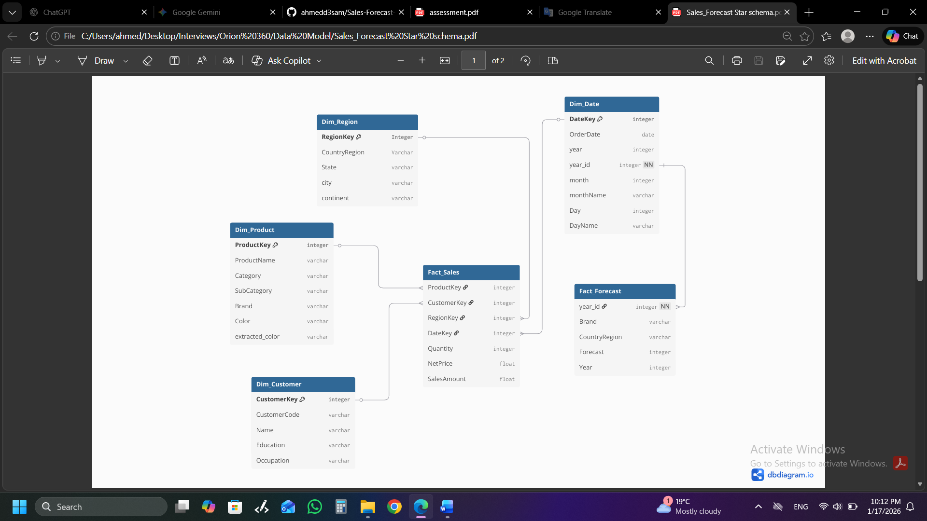
- The Fact Forecast table links to Dim_Date via year_id and to Dim_Region via CountryRegion.

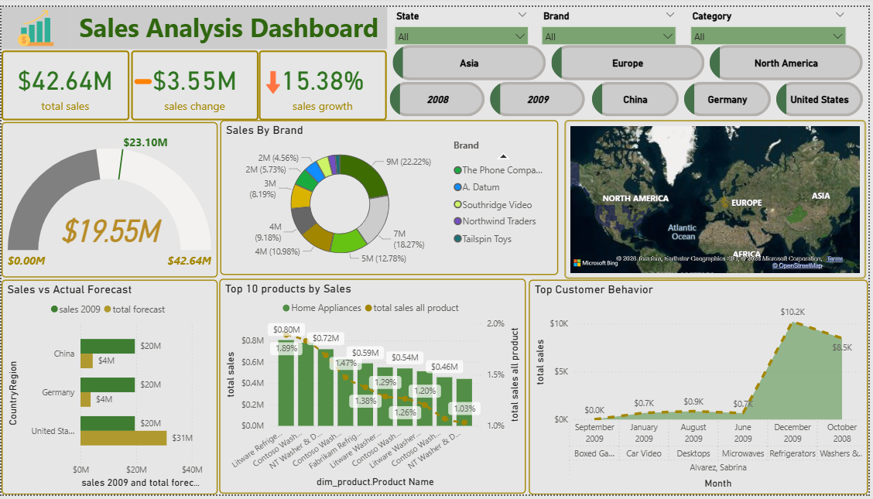
3- Dashboard:
3.1 Executive Summary (KPIs):
- Total Sales: $42.64M, representing the sum of SalesAmount from the sales fact table.
- Sales Change: A negative variance of -$3.55M.
- Sales Growth: A decline of 15.38%.
- Gauge Chart: Shows a current progress of $19.55M against a target of $42.64M.
3.2 Sales by Brand & Product:
- Sales by Brand: A donut chart breaks down performance by brands such as Contoso (23.13%), Tailspin Toys, and Litware.
- Top 10 Products: A bar chart ranks individual products (e.g., Litware Refrigerators, Contoso Washers) by total sales.
3.3 Geographic Distribution:
Using the Dim_Region table, the dashboard filters and maps data by location:
- Interactive Map: Visualizes global sales across North America, Europe, and Asia.
- Region Slicers: Users can filter the entire dashboard by State, Country/Region (e.g., China, Germany, United States), or specific continents.
3.4 Comparative & Trend Analysis:
- Sales vs. Actual Forecast: A horizontal bar chart compares 2009 sales against the total forecast for China, Germany, and the United States, utilizing the relationship between Fact Sales and Fact Forecast.
- Top Customer Behavior: A line chart tracks total sales over time (Months), derived from the Dim_Date table. It highlights peak sales activity in December 2009 ($10.2K).

